**Optimization of a Nuclear-Renewable Hybrid Energy System with Hydrogen Production using Particle Swarm Algorithm**

**Abstract**

This study investigates optimal configurations for Nuclear-Renewable Hybrid Energy System (NHES) to ensure reliable and economically viable operations. We developed a dynamic NHES model capable of meeting electricity demand throughout the year, accounting for the variability of renewable resources and hourly fluctuations in day-ahead electricity prices. Nuclear energy is supplied via NuScale-type small modular reactors (SMRs), while wind and solar generation profiles, along with market prices, were generated using data analytics techniques. Particle Swarm Optimization (PSO) was employed to determine the optimal subsystem capacities that minimize the total system cost, defined as capital and operational expenses minus revenues from electricity and hydrogen sales. Battery energy storage ensured hourly energy balance, and a hydrogen production subsystem was integrated to improve system flexibility and profitability.

**Keywords:** NHES, SMR, Wind, Solar, Hydrogen, PSO

1. Introduction

The rapid expansion of variable renewable energy (VRE) sources—primarily solar photovoltaics and wind—has become central to global decarbonization efforts. While these technologies are pivotal in reducing greenhouse gas emissions, their intermittent nature introduces substantial operational and reliability challenges for electric grids [1].

NHES integrates nuclear power with renewable energy sources—often alongside energy storage, hydrogen production, or thermal processes—in a coordinated architecture that enhances grid flexibility, reliability, and economic performance. By diverting excess renewable or nuclear generation to industrial applications (e.g., chemical production, desalination), NHES reduce curtailment and improve overall system efficiency [2].

NHES is an integrated energy network where nuclear and renewable sources are connected together either directly in a tightly integrated system or in a grid balancing area with the support of energy storage to supply electricity and/or thermal energy to end-users [3].

Three main options for NRHES are identified as: Tightly Coupled Systems: Nuclear, renewable, and industrial components are directly linked and jointly managed behind the grid, with a single grid connection and financial operator. Thermally Coupled Systems: These systems may have multiple grid connection points and are not necessarily co-located, but nuclear and renewable components are still jointly controlled. In this configuration, tight thermal connection between heat source and industrial application is possible. Loosely Coupled, Electricity-Only Systems: These resemble thermally coupled systems in terms of control but include only electrical links between generation and industrial users [4].

In this study, we design and analyze a tightly coupled NHES, where all subsystems—nuclear, renewable, and industrial—are jointly managed behind the grid interface.

The growing need for reliable, low-carbon energy systems has driven increased interest in NHES as they leverage the stability of nuclear energy and the environmental advantages of renewables. These systems offer enhanced energy security, reduced emissions, and improved grid resilience through flexible, multi-vector energy management.

A critical research challenge in NHES lies in the **o**ptimization of system design and operation, considering the stochastic nature of renewables, fluctuating electricity prices, and the techno-economic characteristics of integrated subsystems such as hydrogen production plants.

**Literature summary**

Modeling and optimization studies on NHES covered a wide range of techniques. First studies on the topic focused on modeling without optimization; [5], [6] used first order linear equations to model NHES with SMR, WT, Battery system coupled with a chemical plant. [5] studied dynamic performance of the NHES with different renewable power generation levels. [6] investigated the economics of the hybrid system.

Subsequent studies adopted simulation tools like Modelica to capture the dynamics of subsystem interactions.; [7] modeled two NHES configurations using distinct desalination technologies to meet the electric demand of Salt Lake City, comparing performance based on water production and peak demand response. [8] analyzed an NHES configuration with thermal storage and a hydrogen plant to assess the ability to meet different grid demand scenarios driven by variable renewable penetration. [9] explored the use of high-temperature steam electrolysis (HTSE) as a flexible load, finding it effective for energy dispatch even under high solar and wind input.

Other modeling efforts employed MATLAB/Simulink for dynamic analysis. In [10] SMRs co-producing hydrogen were integrated with a gas turbine to meet New England’s annual electricity demand. [11] used a similar configuration but focused on desalination technologies and system dynamics.

Optimization techniques have gained prominence to improve the economic and operational performance of NHES. Analytical methods, machine learning, linear programming, and metaheuristic algorithms have all been employed: [12] used an interior point method to optimize the operational schedule of two NHES configurations—one coupling SMR with wind and a chemical plant, the other coupling SMR with solar and desalination. [13] extended this work using dynamic Modelica-based representations of the same systems.

[14] and [15] used the RAVEN platform developed by Idaho National Laboratory. [14] applied the Simultaneous Perturbation Stochastic Approximation (SPSA) algorithm with stochastic demand and renewable generation profiles to minimize the Levelized Cost of Electricity (LCOE). Results showed that higher renewable shares significantly increased LCOE. [15] introduced a two-level optimization approach: a lower-level system with unconstrained dispatch and a higher-level Modelica model, using SPSA to optimize component capacities under stochastic demand.

Machine learning has been used for scenario generation and forecasting. For example, [16] integrated renewable forecasts into a stochastic mixed-integer linear programming (MILP) framework for NHES dispatch optimization involving SMRs, desalination, wind, and solar. [17] applied MILP to optimize Ontario’s energy mix, balancing heat and power demands with various generation and storage technologies.

Metaheuristic approaches such as Particle Swarm Optimization (PSO), Genetic Algorithms (GA), and Gravitational Search Algorithm (GSA) have gained traction. [18] compared multiple NRHES configurations using PSO to minimize Net Present Cost (NPC) [19] used GSA to determine optimal unit counts for NRHES configurations in Chabahar, minimizing Total Annualized Cost (TAC) while comparing HTSE and LTSE for hydrogen production. [20] developed an open-source techno-economic optimization model for nuclear-wind-hydrogen systems using GA to minimize internal rate of return (IRR). [21] used GA to design a carbon-free NRHES in Texas, integrating Natrium SMR with molten salt and hydrogen storage. Despite hydrogen contributing only 2.3% of annual generation, it was essential during periods of low renewable output.

Recent developments include deep reinforcement learning (DRL). [22] applied DRL algorithms (PPO, TD3, SAC) to optimize NHES operation by maximizing revenue from electricity and hydrogen sales, comparing results with PSO. DRL strategies achieved comparable or superior results, with PPO yielding the highest returns.

Most existing studies optimize NHES with a single SMR and often assume constant electricity prices. The novelty of this research lies in its multi-unit SMR capacity sizing, simultaneous optimization on both demand and supply sides, and integration of real-time day-ahead electricity market prices. Additionally, this work emphasizes the use of advanced data analytics techniques to generate high-fidelity input datasets, enabling more accurate and economically viable system designs.

1. System Description

The Nuclear Hybrid Energy System (NHES) designed in this study integrates multiple energy sources and storage technologies to ensure operational flexibility, economic efficiency, and grid reliability. The generation subsystem consists of nuclear, wind, and solar energy, while energy storage is achieved through battery systems and hydrogen production. Additionally, a demand component is incorporated to reflect real-time electricity consumption dynamics. Figure X presents the overall system layout, including the interconnections among the various subsystems.

The selected location for NHES deployment is the Urla province in Türkiye, chosen for its favorable renewable energy potential. The region benefits from both high solar irradiance and strong, consistent wind resources. Meteorological data specific to Urla were used for wind speed and solar irradiance profiles. To avoid bias from any single historical year and to enable a more generalized system evaluation, historical data on wind, solar, electricity demand, and market prices were collected across multiple years. These datasets were then used to synthesize a representative annual profile using appropriate generation techniques tailored to each data type. The nuclear subsystem, in contrast to variable renewables, is assumed to produce constant power over time, reflecting the base load nature of nuclear generation.

**2.1 Nuclear Power**

Advanced nuclear technologies, particularly small modular reactors (SMRs), offer the capability for flexible and reliable electricity generation, making them well-suited for integration within hybrid energy systems. Unlike conventional large-scale reactors designed primarily for baseload operation, SMRs are designed with inherent modularity and operational adaptability. This allows for dynamic adjustment of power output and redirection of thermal or electrical energy to auxiliary systems such as hydrogen production or thermal energy storage, especially during periods of renewable energy oversupply or low market electricity prices[23].

In a Nuclear-Renewable Hybrid Energy System (NHES), SMRs can be integrated with industrial systems in two main configurations: (1) thermally coupled systems, where the industrial process utilizes direct thermal output from the reactor, and (2) electrically coupled systems, where the SMR is connected through an electric network, allowing flexibility in power allocation [3]. Our study adopts the latter, coupling the SMR to a hydrogen production system via the electrical grid. This configuration enables rapid operational response to electricity price signals and variable renewable output without requiring frequent changes in the thermal-hydraulic state of the reactor. As a result, the reactor operates in a steady-state mode, maintaining thermal stability while the power distribution to end-uses or to industrial system is adjusted dynamically.

We selected the NuScale SMR as the nuclear subsystem for this study due to its high technology readiness level and commercial availability. NuScale’s modular design provides standardized reactor units, each capable of generating 77 MWe of power. Customers can choose from 4-, 6-, or 12-module configurations depending on system demand and economic considerations [24]. In NuScale’s design, all reactor modules are submerged in a large below-grade pool inside the reactor building, enhancing both passive safety and operational efficiency (fig-x).

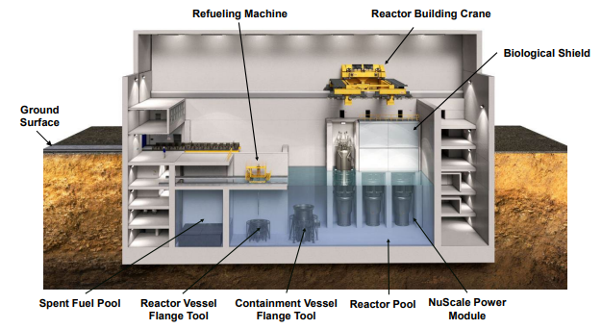

Figure-x: NuScale power modules inside the reactor pool[25]

In our NHES model, the number of deployed NuScale modules is treated as an optimization variable, ranging from 1 to 12. This flexibility allows the optimization algorithm to balance the trade-off between capital cost and operational revenue, depending on market conditions and system requirements. By allowing the nuclear subsystem to act as a baseload provider of the hybrid energy system, while incorporating responsive subsystems like batteries and hydrogen production, the model achieves both reliability and economic flexibility in energy supply.

**2.2 Wind Turbine**

Wind power generation was modeled using wind speed data retrieved from the NASA POWER dataset for the period 2014–2024[26] from wind speed at 50m. Ten year hourly wind speed data sampled using Weibull distribution to generate wind profiles representative of typical annual conditions. Figure X compares the historical NASA data and Synthetic dataset constructed using weibull distribution for wind speed profiles.

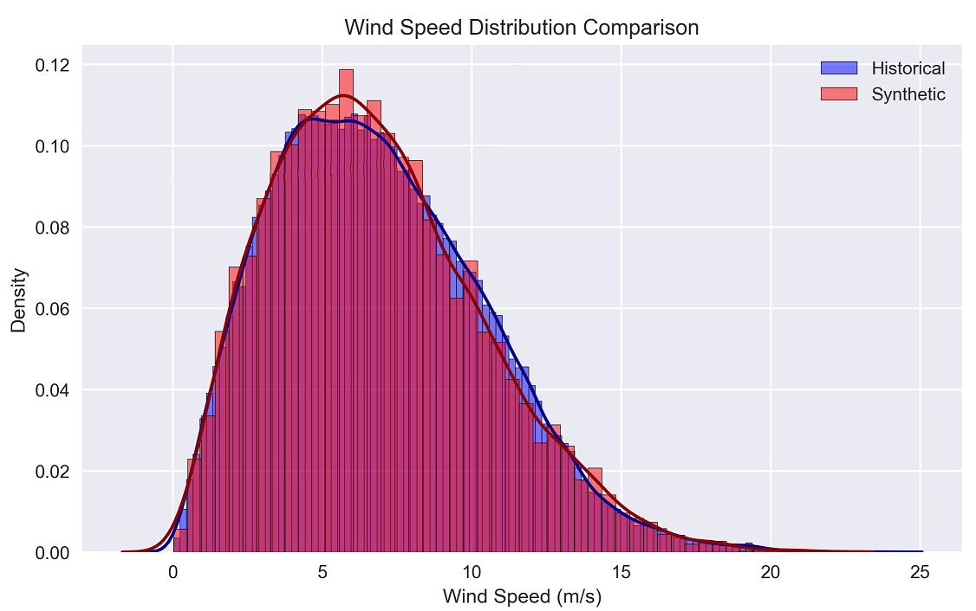

In order to calculate generated power from wind speed, we used standard piecewise-defined power curve, described by Equation(1)

|  |  |
| --- | --- |

where;

In our analysis we used the Vestas V90 2000 model wind turbine. Turbine specifications and simulation parameters are summarized in Table X.

Table-x: Wind turbine specifications [ref?]

| **Parameter** | **Value** |
| --- | --- |
| Turbine hub height [] | 80 m |
| Cut-in wind speed [] | 4 m/s |
| Cut-out wind speed [] | 25 m/s |
| Rated wind speed [] | 13 m/s |
| Rated power of the turbine [] | 2000 kW |
| Wind shear coefficient [] | 0.14 |

**2.3 Solar Power**

Solar PV generation was calculated based on hourly values of solar irradiance and ambient temperature for the years 2014–2024.

The output power from a solar PV panel was estimated using Equation.

is the solar irradiance and is calculated from equation (2)

Efficiency of panel () and calculated from equation(3)

: Panel efficiency at reference temperature

: Cell temperature

: Reference temperature

Global Horizontal Irradiance (GHI),,clearness index (ALLSK_KT) and temperatures were retrieved from NASA POWER database[26]. P_out is then calculated for between 2014-2024 considering hourly efficiency and solar irradiance for A=1.6 m2 panel and power output of a single panel is listed for that time period. Later, data were processed using the Typical Meteorological Year (TMY) sampling method, which selects the most representative months from the dataset based on key statistical metrics. The month that best represents the dataset and sampling metrics were given in table -x.

Table -x: TMY statistics

| **TMY parameters** | **Years for TMY months** |
| --- | --- |
| Mean Bias: 12.45 W  RMSE: 19.45 W  Monthly Correlation: 0.861  Standard Deviation Ratio: 0.780  Annual Energy Production: 424.5 kWh  Peak Power Output: 225.0 W  Average Daily Energy: 1.2 kWh  Capacity Factor: 21.5% | Month 1: 2024  Month 2: 2016  Month 3: 2016  Month 4: 2022  Month 5: 2024  Month 6: 2020  Month 7: 2019  Month 8: 2015  Month 9: 2023  Month 10: 2020  Month 11: 2023  Month 12: 2021 |

According to calculation, a single solar panel produces 424.5 kWh power annually with 21.5 % capacity factor. Seasonal variations in the solar generation were shown in figure -x.

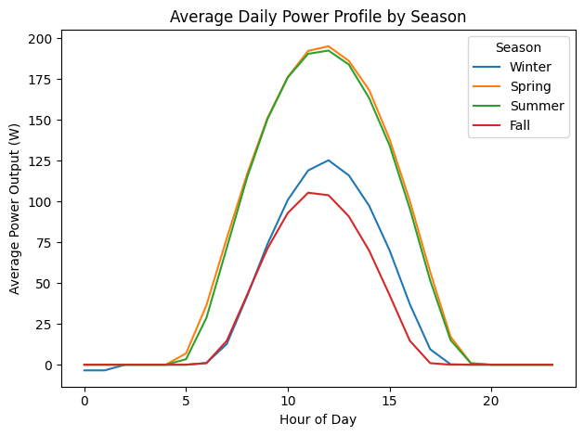

Figure-x:

**2.4 Electricity Market**

The NHES economic performance was evaluated under the assumption that electricity is sold in the day-ahead electricity market, alongside hydrogen as an alternative revenue stream. Hourly electricity price data spanning 2014–2024 were gathered from the relevant market database.

To account for price variability and stochastic market behavior, a synthetic one-year hourly electricity price dataset was generated using the XGBoost (Extreme Gradient Boosting) algorithm. XGBoost is a supervised machine learning technique based on decision trees and ensemble learning, capable of capturing nonlinear trends and interactions among features.

The dataset was split into training and testing sets. Model training was performed on the training set, and model accuracy was evaluated against the test set. Table X summarizes the most important predictive features used in the model, such as month, hour, day-of-week, and lagged price values.

Model performance was assessed using common statistical metrics such as Mean Absolute Error (MAE) and Root Mean Square Error (RMSE). The predicted hourly price trajectory and its comparison with test data are shown in Figure X. The resulting synthetic price signal for a full year was used as input to the NHES economic optimization model.

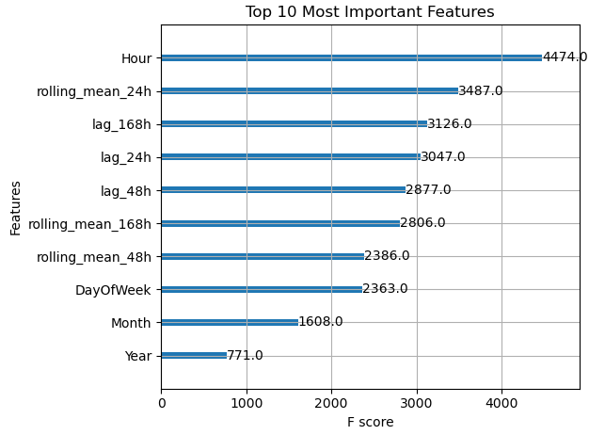

We splitted the data into train and test datasets. XQBoost model developed using train dataset and the performance of the model measured with comparison between test dataset and model findings. Figure-x shows the forecasted data and test data.

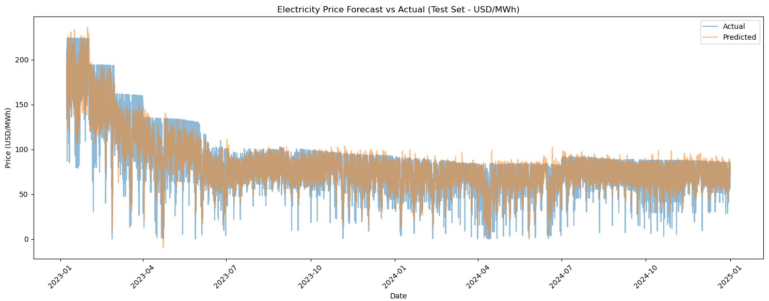

Synthetic hourly electricity price data generated for one year is shown in figure-x.

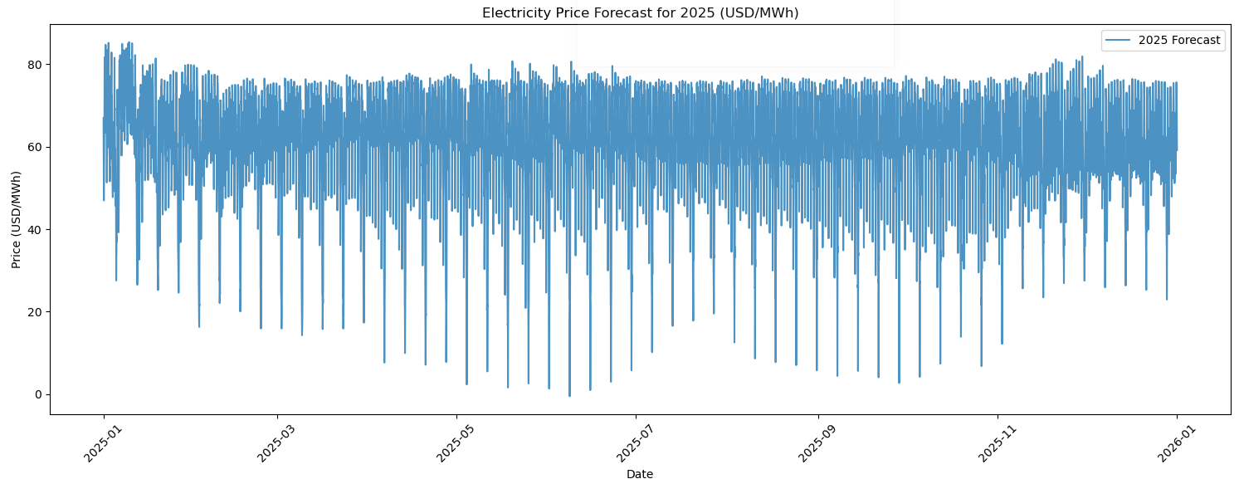

**2.5 Demand**

In order to ensure grid reliability, the NHES configuration in this study was designed based on the national electricity demand profile, as the Turkish electricity market operates under a single-zone pricing structure, where supply and demand are balanced on a country-wide basis.

We retrieved actual demand for the years between 2016-2024. Using the same approach applied to electricity price forecasting, the XGBoost algorithm was employed to generate one year of hourly demand data. The forecasting model achieved a mean absolute percentage error (MAPE) of 0.0178, indicating high predictive accuracy. Figure X illustrates the close agreement between actual and forecasted data. The generated demand profile used in the analysis is shown in Figure Y. Since the NHES is not designed to meet the entire national demand, the profile was scaled down to a peak capacity of 1000 MWe.

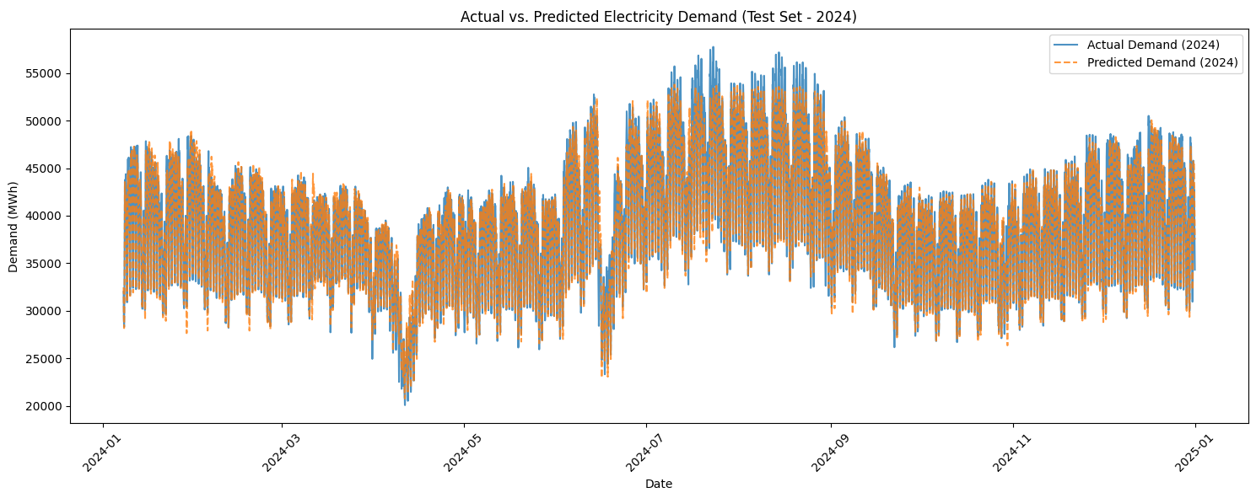

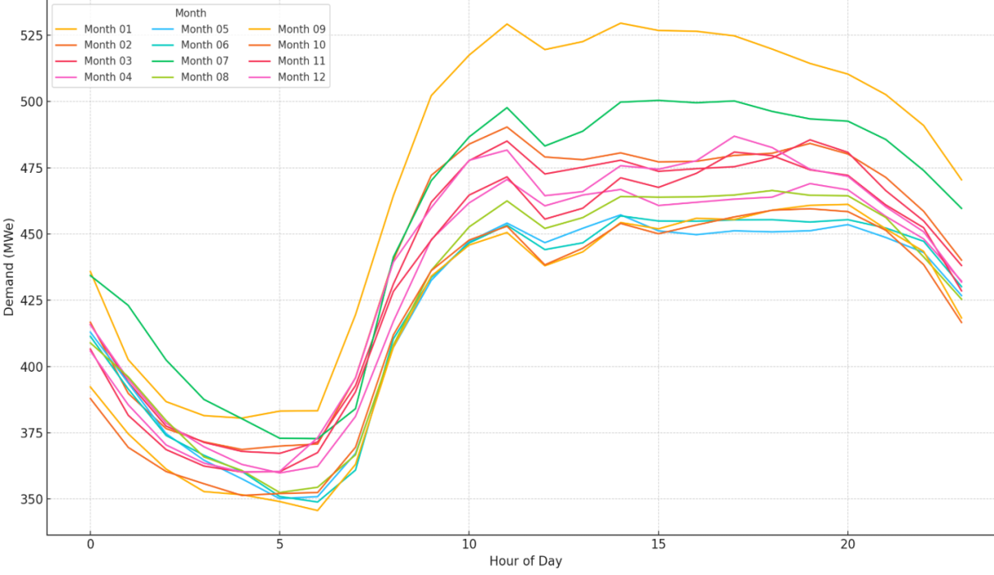

**2.5 Hydrogen System**

The hydrogen system utilizes excess electricity for hydrogen production and consists of three main components: Electrolyzer, which produces hydrogen using electricity, Hydrogen storage, for storing the produced hydrogen, and Fuel cell units, which convert stored hydrogen back into electricity when needed.

In this study, Low-Temperature Electrolysis (LTE) was adopted for hydrogen production using only surplus electricity. PEM electrolyzers were used for LTE, where hydrogen is produced via an electrochemical reaction powered by electricity.

A linear relationship between the electricity directed to the electrolyzer and the amount of hydrogen produced is given by equation()

Where:

* : Electrolyzer efficiency
* : Electricity required per kg H₂ (kWh/kg)

Typical values for ε, electricity required for producing 1kg hydrogen is between 50 to 60 kWh . We used 55 kWh/kg H2 for ε and for efficiency(η) of LTE we used 0.57[27].

Hydrogen produced in hour t, compressed to the hydrogen tank. Hydrogen in these storages is used for selling the hydrogen in the market. Hydrogen mass balance inside the storage is written as in equation ().

The amount of hydrogen that can be send to tank for hour t, is limited by production of hydrogen at hour t, or the remaining capacity inside the hydrogen tank. Hydrogen system in the design has a one hour time for transporting hydrogen out of the tank so only the produced hydrogen from previous hour can be remain in the tank. Therefore remaining capacity in the tank is total capacity of the hydrogen storages () minus.

**2.6 Battery Model**

Battery energy storage systems are employed to absorb surplus electricity during low-demand periods and discharge during high-demand periods to improve grid reliability and economic performance. In this study, we use utility-scale lithium-ion battery systems with a 4-hour duration, where each unit has a storage capacity of 1000 kWh. This implies that each battery can be fully charged or discharged in four hours. The operational logic is governed by the battery’s State of Charge (SOC), which tracks energy content over time. Charging and discharging behaviors are modeled based on the net energy balance and battery constraints

Net energy, the difference between production and demand for time t is calculated as:

If > 0:

Batteries are charged:

Then the electricity sold to the grid is:

If < 0:

Batteries are discharged:

Then the electricity sold to the grid is:

**2.7 Dispatch Strategies**

Efficient dispatch of energy resources is critical in hybrid energy systems, especially when integrating variable renewable sources with firm nuclear generation and flexible storage assets. In this study, two different dispatch strategies were implemented and compared under varying system configurations: a simple rule-based approach and an advanced Model Predictive Control (MPC)-based optimization.

**2.7.1 Rule-Based Dispatch**

The rule-based dispatch strategy relies on a predefined priority order and operational heuristics to allocate power generation and storage usage on an hourly basis. At each time step, power produced is calculated from SMR plus Renewables. SMR operates at a constant output since no load follow with turbine by-pass considered. Renewable sources (solar and wind) generate based on resource availability. And this hourly production is higher than the demand battery charging is activated, if it is lower than the demand at that hour battery discharge triggered which are subject to SOC and power limits. Electricity that is covered the demand is sold and generates revenue. In hydrogen-integrated cases, excess generation is also directed to electrolyzers for hydrogen production after the battery storage is fully charged. While simple and easy to implement, rule-based dispatch cannot adapt to price variations or forecasted system states, which may lead to suboptimal operation.

**2.7.2 Optimized Dispatch**

The optimized dispatch strategy formulates the hourly operation of the system as a constrained optimization problem, solved over a finite prediction horizon (24 hours). The objective is to maximize daily revenue from electricity over a 24-hour horizon by optimally dispatching battery storage, while considering generation, demand, and storage constraints.

In our model, simultaneous charging and discharging is permitted, as the battery system is composed of multiple parallel battery packs that can independently operate in charging or discharging modes. This assumption avoids the need for binary variables and preserves the convexity of the problem.

As a result, the dispatch problem is formulated as a Convex Quadratic Program (QP). The convex structure ensures that the solution is globally optimal and computationally efficient. The problem is solved using the Operator Splitting Quadratic Program (OSQP) solver, which is well-suited for large-scale QP problems with linear constraints.[ref]

This optimization framework determines the optimal charging and discharging schedule of the battery system for each hour of the day, with the goal of maximizing the total revenue from electricity sales.

.

At each day, a rolling-horizon optimization is performed and only the first-hour dispatch decision is implemented. This allows MPC to adapt daily to forecast uncertainty while enforcing feasible and near-optimal system operation.

1. Methodology

**3.1 Objective Function**

In order to efficiently size each system capacity, we aim to maximize the revenue earned from selling electricity and hydrogen. This revenue is accumulated from hourly sales, where the operator either sells electricity at the market price or uses electricity to produce hydrogen to sell in the hydrogen market. The aim of this study is to investigate the economic profitability of the NHES system that generates adequate electricity matching the demand at a given time. For this purpose, we define the profit for the one-year simulation period by considering the annual CAPEX and OPEX as shown in the equation().

Annual Revenue is calculated by multiplication of amount electricity sold at time t, with the price of electricity at that time, if hydrogen system is integrated in NHES than yearly hydrogen revenue is also added to annual revenue.

**Annual O&M Cost (OPEX):**

Where:

* i ∈ {SMR, wind, solar, battery, hydrogen}
* ​: Number of units of subsystem i
* ​: Capacity per unit of subsystem i
* : O&M cost per kW for subsystem i

**Annual CAPEX:**

Capital cost of the NHES is annualized by capital recovery factor.

Where:

* ​: Capital cost per kW for subsystem i
* : Capital recovery factor for subsystem i, with discount rate r and lifetime

Annual profit is calculated as:

Economic parameters that are used in the calculations of CAPEX and OPEX values are given in table-x. For the capital recovery factor, a discount rate of 5% and a project lifetime of 60 years are used.

**Table-x:** Overnight Capital Cost (OCC) and Operating expenses (OPEX) for NHES subsystems

| **Subsystem** | **OCC [$/kWe]** | **OPEX** | **Lifetime [years]** |
| --- | --- | --- | --- |
| SMR[28] | 6000 | 25 $/MWh | 60 |
| Wind[29] | 1600 | 30 $/kW-year | 30 |
| Solar[29] | 1500 | 20 $/kW-year | 20 |
| Battery[30] | 400 | 10 $/kWh | 15 |
| Hydrogen[31] | 1800 | 90 $/kWh* | 20 |

*: including O&M and miscellaneous expenses (2.5% of capital cost for each)

Since the system should also have good demand-matching performance (i.e., load-following capacity), we implemented a penalty function in the objective of the optimization algorithm. This penalty function measures how well the system follows demand by comparing electricity sold with demand, as described in the equation().

This function accounts for the annual total deviation from demand since the profit is also calculated annually. Unlike the traditional approach, we also penalize overproduction, as the planned NHES should contribute to grid stability by providing adequate electricity even in low-demand periods.

The overall objective function is defined as in equation().

A weight factor is implemented to arrange impacts of the design performance on gaining profits or matching efficiency of demand is used to balance the effect of maximizing profit versus matching demand. To increase profitability and reduce unmet demand penalties, the function f(x) is maximized in the optimization process.

**Constraints**

The number of units for each subsystem in the NHES is selected as a decision variable, since the total electricity generation and associated costs depend on the overall capacities of these subsystems. Each variable adds a dimension to the optimization algorithm. Therefore, the number of units for each subsystem is limited as shown below.

**PSO Algorithm**

Particle Swarm Optimization (PSO) is a population-based metaheuristic inspired by the social behavior of birds and fish[32] .In this study, PSO is employed to optimize the component configuration of a hybrid energy system consisting of nuclear (SMR), wind, solar, and battery units. The objective is to maximize economic performance while ensuring electricity demand is met reliably.

Each candidate solution, or “particle,” represents a unique combination of component counts: small modular reactors (SMRs), wind turbines, solar units, and battery storage units. The search space is explored iteratively by updating the positions and velocities of these particles based on both individual (personal best) and collective (global best) experience within the swarm.

The objective function evaluated for each particle simulates 8760 hours of system operation, calculates electricity generation, battery charging/discharging behavior, and computes the resulting revenue, operational cost, and capital investment. The fitness value is formulated as:

Here, profit is calculated as annual revenue minus annual costs, and the penalty term quantifies the mismatch between electricity supply and demand. Since the PSO algorithm aims for the minimization, a minus sign is added for maximization.

The PSO algorithm progresses as shown in Figure X. It begins by initializing a swarm of particles with random positions in the search space. In each iteration, the objective function is evaluated for every particle. Based on performance, particles update their velocities and move in the direction of their personal and the global best solutions. This process continues until a stopping criterion—typically a maximum number of iterations—is met.

**3.2 Case 1: NHES without Hydrogen system**

The first case examines the NHES design by only considering battery system for electricity storage. So there is no system to produce hydrogen and hydrogen revenue is not possible. We used rule based dispatch to determine battery charge / discharge behavior.

For each hour hourly production is calculated from equation

**3.3 Case 2: NHES with Hydrogen system**

1. Results

4.1 Optimum Configurations

The Particle Swarm Optimization (PSO) algorithm was used to determine the most economical configuration of the Nuclear-Renewable Hybrid Energy System (NHES) under two scenarios: Case 1 without hydrogen production, and Case 2 with integrated hydrogen production and storage.

Table 4.1 summarizes the optimal number of system components, along with the corresponding Net Present Value (NPV), Levelized Cost of Electricity (LCOE), Levelized Cost of Hydrogen (LCOH, for Case 2), and unmet demand ratio.

Table 4.1

|  |  |  |  |  |  |  |  |  |
| --- | --- | --- | --- | --- | --- | --- | --- | --- |
| Case | #SMRs | #Wind Turbines | #Solar Panels | #Batteries | #Electrolyzers | LCOE, LCOH | NPV | Demand Match |
| 1(No ) |  |  |  |  |  |  |  |  |
| 2(With ) |  |  |  |  |  |  |  |  |

The optimization results show that in both cases, the hybrid system relies heavily on a combination of nuclear and renewable generation to meet demand and minimize costs. In Case 2, hydrogen production enhances the system’s economic performance, with a 21% improvement in NPV and a slight reduction in LCOE. Additionally, the hydrogen system contributes to better flexibility, reducing unmet demand.

In both cases, battery storage plays a significant role in balancing the system, although hydrogen storage and electrolyzers take over part of the flexibility requirement in Case 2. The higher number of wind turbines and solar panels in the hydrogen-integrated case also reflects a shift towards exploiting excess renewable energy for hydrogen production.

**4.2 Hourly Operation Analysis**

Four representative days from different seasons (Days 16, 101, 173, and 281) were selected to analyze hourly generation, battery state of charge (SOC), and electricity sold. Figure 4.1 illustrates the power output from SMRs, wind and solar generation, battery SOC, electricity sold, total generation, and demand for each selected day.

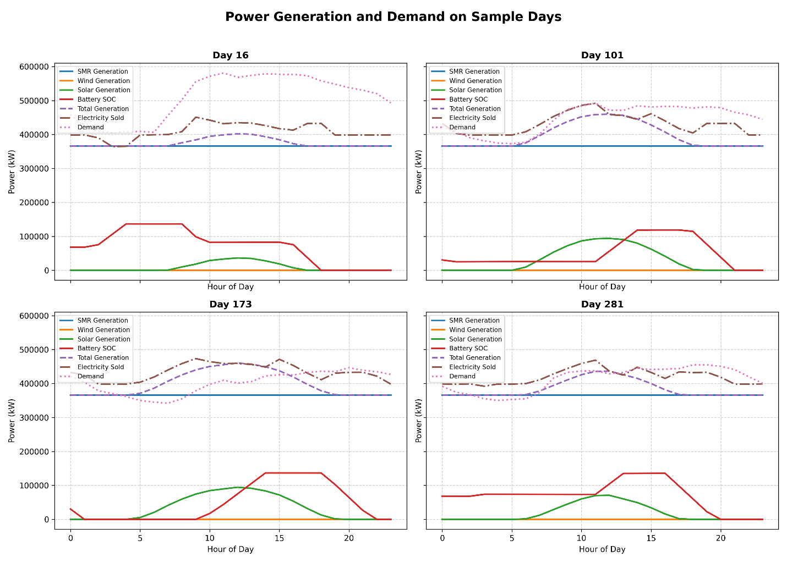

Figure 4.1. Hourly power generation, demand, and battery SOC for selected days.

On Day 16 (winter), renewable generation was minimal, especially solar power, and the system relied heavily on nuclear generation and battery discharge to meet demand. The battery SOC shows periods of discharge during peak hours and remains idle during the night.

On Day 101 (spring), both wind and solar generation increased. Solar power contributed significantly between 9:00 and 17:00, and the battery was charged during midday. Electricity was sold during periods when generation exceeded demand.

Day 173 (summer) experienced the highest solar generation, with the battery being fully charged during midday and partially discharged in the evening. SMRs provided a steady base load throughout the day, while renewables covered daytime peaks. Surplus generation was sold during early afternoon hours.

On Day 281 (autumn), wind generation became the dominant renewable source, peaking between 6:00 and 14:00. Battery charging occurred mostly during late morning, followed by moderate discharge in the evening to meet evening demand.

**4.3 Economic Indicators**

The economic performance of the hybrid energy system was assessed using three main financial metrics: Net Present Value (NPV), Levelized Cost of Electricity (LCOE), and, for the hydrogen-integrated case, Levelized Cost of Hydrogen (LCOH). For both Case 1 (without hydrogen) and Case 2 (with hydrogen), Table 4.2 summarizes the economic indicators over a 60-year project lifetime. Revenues were calculated based on electricity sold to the grid and, in Case 2, additional income from hydrogen sales. Operating costs include fixed and variable operation and maintenance (O&M) expenses, while capital costs are amortized annually and include periodic component replacements.

1. Discussion

Even with high temperature electrolyzers (even above 100C) efficiency rises and required electricity drops significantly[27] therefore thermal connection between SMR and Hydrogen system can improve the efficiency of hydrogen production.

1. References

[1] IAE, “Status of Power System Transformation,” IAE, Paris, 2019. [Online]. Available: https://www.iea.org/reports/status-of-power-system-transformation-2019

[2] M. F. Ruth, O. R. Zinaman, M. Antkowiak, R. D. Boardman, R. S. Cherry, and M. D. Bazilian, “Nuclear-renewable hybrid energy systems: Opportunities, interconnections, and needs,” *Energy Convers. Manag.*, vol. 78, pp. 684–694, Feb. 2014, doi: 10.1016/j.enconman.2013.11.030.

[3] *Nuclear–Renewable Hybrid Energy Systems*. in Nuclear Energy Series, no. NR-T-1.24. Vienna: INTERNATIONAL ATOMIC ENERGY AGENCY, 2023. [Online]. Available: https://www.iaea.org/publications/15098/nuclear-renewable-hybrid-energy-systems

[4] S. M. Bragg-Sitton *et al.*, “Nuclear-Renewable Hybrid Energy Systems: 2016 Technology Development Program Plan,” INL/EXT--16-38165, 1333006, Mar. 2016. doi: 10.2172/1333006.

[5] H. E. Garcia, A. Mohanty, W.-C. Lin, and R. S. Cherry, “Dynamic analysis of hybrid energy systems under flexible operation and variable renewable generation – Part I: Dynamic performance analysis,” *Energy*, vol. 52, pp. 1–16, 2013, doi: https://doi.org/10.1016/j.energy.2013.01.022.

[6] H. E. Garcia, A. Mohanty, W.-C. Lin, and R. S. Cherry, “Dynamic analysis of hybrid energy systems under flexible operation and variable renewable generation – Part II: Dynamic cost analysis,” *Energy*, vol. 52, pp. 17–26, 2013, doi: https://doi.org/10.1016/j.energy.2012.11.032.

[7] S. Hills, S. Dana, and H. Wang, “Dynamic modeling and simulation of nuclear hybrid energy systems using freeze desalination and reverse osmosis for clean water production,” *Energy Convers. Manag.*, vol. 247, p. 114724, Nov. 2021, doi: 10.1016/j.enconman.2021.114724.

[8] G. C. Masotti, A. Cammi, S. Lorenzi, and M. E. Ricotti, “Modeling and simulation of nuclear hybrid energy systems architectures,” *Energy Convers. Manag.*, vol. 298, p. 117684, Dec. 2023, doi: 10.1016/j.enconman.2023.117684.

[9] J. S. Kim, R. D. Boardman, and S. M. Bragg-Sitton, “Dynamic performance analysis of a high-temperature steam electrolysis plant integrated within nuclear-renewable hybrid energy systems,” *Appl. Energy*, vol. 228, pp. 2090–2110, 2018, doi: https://doi.org/10.1016/j.apenergy.2018.07.060.

[10] A. Ho, K. Mohammadi, M. Memmott, J. Hedengren, and K. M. Powell, “Dynamic simulation of a novel nuclear hybrid energy system with large-scale hydrogen storage in an underground salt cavern,” *Int. J. Hydrog. Energy*, vol. 46, no. 61, pp. 31143–31157, Sep. 2021, doi: 10.1016/j.ijhydene.2021.07.027.

[11] A. Ho, B. W. Billings, J. D. Hedengren, and K. M. Powell, “Flexible operation of nuclear hybrid energy systems for load following and water desalination,” *Renew. Energy Focus*, vol. 51, p. 100641, 2024, doi: https://doi.org/10.1016/j.ref.2024.100641.

[12] J. Chen, H. E. Garcia, J. S. Kim, and S. M. Bragg-Sitton, “Operations Optimization of Nuclear Hybrid Energy Systems,” *Nucl. Technol.*, vol. 195, no. 2, pp. 143–156, Aug. 2016, doi: 10.13182/NT15-130.

[13] H. E. Garcia *et al.*, “Dynamic performance analysis of two regional Nuclear Hybrid Energy Systems,” *Energy*, vol. 107, pp. 234–258, Jul. 2016, doi: 10.1016/j.energy.2016.03.128.

[14] T. E. Baker, A. S. Epiney, C. Rabiti, and E. Shittu, “Optimal sizing of flexible nuclear hybrid energy system components considering wind volatility,” *Appl. Energy*, vol. 212, pp. 498–508, Feb. 2018, doi: 10.1016/j.apenergy.2017.12.061.

[15] A. Epiney, C. Rabiti, P. Talbot, and A. Alfonsi, “Economic analysis of a nuclear hybrid energy system in a stochastic environment including wind turbines in an electricity grid,” *Appl. Energy*, vol. 260, p. 114227, Feb. 2020, doi: 10.1016/j.apenergy.2019.114227.

[16] D. V. Pombo, H. W. Bindner, S. V. Spataru, P. E. Sørensen, and M. Rygaard, “Machine learning-driven energy management of a hybrid nuclear-wind-solar-desalination plant,” *Desalination*, vol. 537, p. 115871, Sep. 2022, doi: 10.1016/j.desal.2022.115871.

[17] P. Sanongboon and T. Pettigrew, “Hybrid energy system optimization model: Electrification of Ontario’s residential space and water heating case study,” *Energy Clim. Change*, vol. 3, p. 100070, Dec. 2022, doi: 10.1016/j.egycc.2021.100070.

[18] H. A. Gabbar, M. R. Abdussami, and Md. I. Adham, “Optimal Planning of Nuclear-Renewable Micro-Hybrid Energy System by Particle Swarm Optimization,” *IEEE Access*, vol. 8, pp. 181049–181073, 2020, doi: 10.1109/ACCESS.2020.3027524.

[19] S. M. Mahmoudi, A. Maleki, and D. R. Ochbelagh, “Techno-economic assessment of hydrogen-based energy storage systems in determining the optimal configuration of the nuclear-renewable hybrid energy system,” *Energy Rep.*, vol. 11, pp. 4713–4725, 2024, doi: https://doi.org/10.1016/j.egyr.2024.04.029.

[20] T. Zhang, “Techno-economic analysis of a nuclear-wind hybrid system with hydrogen storage,” *J. Energy Storage*, vol. 46, p. 103807, Feb. 2022, doi: 10.1016/j.est.2021.103807.

[21] J. Bryan, A. Meek, S. Dana, M. S. Islam Sakir, and H. Wang, “Modeling and design optimization of carbon-free hybrid energy systems with thermal and hydrogen storage,” *Int. J. Hydrog. Energy*, vol. 48, no. 99, pp. 39097–39111, Dec. 2023, doi: 10.1016/j.ijhydene.2023.03.135.

[22] Z. Yi *et al.*, “Deep reinforcement learning based optimization for a tightly coupled nuclear renewable integrated energy system,” *Appl. Energy*, vol. 328, p. 120113, Dec. 2022, doi: 10.1016/j.apenergy.2022.120113.

[23] M. Temiz and I. Dincer, “Development of a hybridized small modular reactor and solar-based energy system for useful commodities required for sustainable cities,” *Energy*, vol. 286, p. 129562, 2024, doi: https://doi.org/10.1016/j.energy.2023.129562.

[24] “VOYGR SMR Plants | NuScale Power.” Accessed: Dec. 14, 2024. [Online]. Available: https://nuscale-prod-chehosfil-nuscale-power.vercel.app/products/voygr-smr-plants

[25] NuScale Power, “NuScale Small Modular Reactor Integration for Hydrogen and Ammonia Production,” NuScale Power, 2022. [Online]. Available: https://www.nuscalepower.com/hubfs/Website/Files/Technical%20Publications/nuscale-small-modular-reactor-integration-for-hydrogen-and-ammonia-production.pdf

[26] “NASA POWER | Prediction Of Worldwide Energy Resources.” Accessed: Dec. 16, 2024. [Online]. Available: https://power.larc.nasa.gov/

[27] A. Franco and C. Giovannini, “Recent and Future Advances in Water Electrolysis for Green Hydrogen Generation: Critical Analysis and Perspectives,” *Sustainability*, vol. 15, no. 24, 2023, doi: 10.3390/su152416917.

[28] A. Abou-Jaoude, L. Lin, C. Bolisetti, E. Worsham, L. Larsen, and A. Epiney, “Literature Review of Advanced Reactor Cost Estimates,” INL/RPT--23-72972-Rev000, 1986466, Jun. 2023. doi: 10.2172/1986466.

[29] NREL (National Renewable Energy Laboratory), “‘2024 Annual Technology Baseline.’ Golden, CO: National Renewable Energy Laboratory.” Accessed: Mar. 30, 2025. [Online]. Available: https://atb.nrel.gov/

[30] W. Cole and A. Karmakar, “Cost Projections for Utility-Scale Battery Storage: 2023 Update,” National Renewable Energy Laboratory, Golden, CO:, NREL/TP-6A40-85332. [Online]. Available: https://www.nrel.gov/docs/fy23osti/85332.pdf

[31] M. H. A. Khan *et al.*, “Designing optimal integrated electricity supply configurations for renewable hydrogen generation in Australia,” *iScience*, vol. 24, no. 6, p. 102539, 2021, doi: https://doi.org/10.1016/j.isci.2021.102539.

[32] J. Kennedy and R. Eberhart, “Particle swarm optimization,” in *Proceedings of ICNN’95 - International Conference on Neural Networks*, 1995, pp. 1942–1948 vol.4. doi: 10.1109/ICNN.1995.488968.